Final Paper
Perceived Scarcity and Consumer Decision-Making: Effects on Purchase Intention and Regret

Mika Ismayilli, Erica Kim, Anna Wei, Pin-Chen Kuo, Rita Feng
Group 09

Introduction & Research Problem

Online purchases occur on a daily basis. From groceries to clothes and from necessities to nonessentials, consumers are constantly making decisions about what to add to their cart and which items to check out. However, beyond simply buying a product, purchasing behavior is often influenced by subtle cues within the shopping environment, and one such cue is scarcity-related messaging. Messages such as “Only 3 left in stock” or “Low on Stock” may create a sense of urgency for buyers, even when the product itself is not inherently urgent.
What remains unclear is the extent to which this perceived scarcity influences decision-making, as specific words, phrases, and low numerical cues have the ability to psychologically influence individuals’ reactions. This marketing strategy raises the central question of the project: Does scarcity messaging (e.g., "Only 3 left in stock") influence consumers' purchase likelihood, perceived urgency, and anticipated regret compared to a neutral availability message? In this study, we focus on college students between the ages of 18 to 25 to understand how perceived scarcity shapes both behavioral intention and emotional response.

Hypothesis

We hypothesize that the presence of a scarcity message (e.g., “Only 3 left in stock”) on an e-commerce product listing increases consumers’ likelihood of purchase, perceived urgency, and anticipated regret compared to a neutral availability message (e.g., “In stock. Available.”).

H₀: There is no effect of scarcity messaging on consumers’ purchase likelihood, perceived urgency, or anticipated regret.
H_{a}: There is a positive effect of scarcity messaging on consumers’ purchase likelihood, perceived urgency, and anticipated regret.
Methodology
Participants
A total of 60 respondents participated in this study. Participants consisted of university students recruited through convenience sampling, comprising 33 males, 23 females, and 4 non-binary individuals. The majority of participants (42 out of 60) were ages 22–25, with the remaining 18 ages 18–21. In terms of academic standing, 37 participants were graduate students and 23 were undergraduates. All participants reported some degree of online shopping experience, with the majority describing themselves as moderately price-sensitive (30) and purchasing online sometimes, roughly 1–2 times per month (30).

Experimental Design and Randomization
This study employed a between-subjects experimental design. Participants were randomly assigned to one of two conditions: a treatment group (n = 33) or a control group (n = 27). Both groups were presented with three product listings. In the treatment condition, each product listing displayed a scarcity message (“Only 3 left in stock”), while the control condition displayed a neutral availability message (“In stock. Available.”). All other aspects of the product listings were held constant across conditions.
For each of the three products, respondents rated their purchase likelihood, perceived urgency to buy, and anticipated regret if they did not purchase the item. All three dependent variables were measured on a 5-point Likert scale. This within-subject repetition across three products yielded 180 total observations in the long-format dataset, allowing for more robust estimation of treatment effects.
Measures
The survey captured both dependent and independent variables as well as individual-difference covariates. The dependent variables were:

Purchase Likelihood – rated from 1 (Extremely unlikely) to 5 (Extremely likely).
Perceived Urgency – rated from 1 (Not urgent at all) to 5 (Extremely urgent).
Anticipated Regret – rated from 1 (None at all) to 5 (A great deal).
Individual-difference covariates included price sensitivity (4-point scale), online purchase frequency (4-point scale), self-reported impulsiveness (5-point scale), agreement with impulse-buying tendencies (5-point Likert), and agreement with the influence of scarcity on one’s own purchasing behavior (5-point Likert). Demographic variables captured were age range, gender, and student status (graduate or undergraduate).
Pre-Experiment Randomization Check
After random assignment, we conducted a randomization check to verify balance between the treatment and control groups. Of the 60 respondents, 33 (55%) were assigned to the treatment condition and 27 (45%) to the control condition. A proportion z-test was used to assess whether this split deviated significantly from a 50/50 allocation. The test yielded a z-statistic of 0.7746 and a p-value of 0.4386, indicating that we failed to reject the null hypothesis of proper randomization. In simpler terms, there is no significant difference between the treatment and control group proportions, suggesting that the randomization procedure was adequate.

Sample | % in Treatment | P-Value
Treatment | 55% | 0.4386
Pre-Experiment Randomization Check

Survey Design & Data Collection
To address our research questions, we designed and administered an online survey using Qualtrics (see appendix). The questionnaire was distributed through social media platforms to reach our target population of college students aged 18 to 25. Participants were randomly assigned to treatment or control groups using Qualtrics’ built-in randomization feature to ensure internal validity.
The survey began with demographic questions, including age range, gender, and academic status (undergraduate or graduate student). In subsequent analyses, we restrict the sample to respondents within our target age range to maintain consistency with our research focus and ensure data quality. Next, we collected information on participants’ purchasing behaviors and psychological tendencies. Using Likert-scale measures ranging from “Not at all” / “Strongly disagree” to “Extremely” / “Strongly agree,” participants self-evaluated their levels of price sensitivity, frequency of online purchasing, impulsiveness in purchasing decisions, frequency of impulsive purchases, and their attraction to limited stock. These additional measures serve as behavioral and psychological proxies that allow us to examine which individual characteristics are associated with greater susceptibility to scarcity messaging. By incorporating these variables, we are able to explore not only the overall effect of limited-stock messaging on purchase intention and post-purchase regret, but also heterogeneity in treatment effects across different consumer profiles.
In the product question section, we focused on evaluating the impact of scarcity messaging on purchase intention. To capture potential differences across price levels, we selected three products representing low-, medium-, and high-priced categories: toilet paper (low price), a power bank (medium price), and a bluetooth speaker (high price). The products were strategically selected with the intent to remain as gender-neutral as possible, and for each product, participants were presented with a hypothetical scenario in which they were browsing online and currently had a genuine need for that type of item. In the scenario, they encountered the listed products — either all being “In Stock” or “Only 3 Left” — displayed in the survey.
Each product was described as belonging to an unfamiliar brand but included general specifications and standard product information to ensure realism. Specifically, participants were shown a product image without any brand icons, product name, brand name, price, and a brief product description including product specifications. In the treatment condition, all three products displayed the scarcity message: “Only 3 left in stock. Buy now!” In the control condition, the message read: “In stock. Available.” Both messages were presented in bold font to ensure equal visual salience and to make the key availability information clearly noticeable across conditions.
After viewing each product, participants responded to three Likert-scale questions: (1) “How likely are you to purchase this item?”, (2) “How urgent does this purchase feel to you?”, and (3) “If you did not purchase this item now, how much regret would you feel?” These measures allowed us to capture participants’ behavioral intentions and emotional reactions across different price levels under scarcity versus non-scarcity conditions. Finally, participants were asked to indicate which availability message they saw, either “Only 3 left in stock” or “In stock. Available.” This served as a manipulation check to identify participants’ assigned groups more accurately and ensure the validity of the responses.

Analysis
To estimate the causal effect of scarcity messaging on consumer behavior, we employed a series of ordinary least squares (OLS) regression models with increasing complexity. Because participants were randomly assigned to either the treatment or control condition via Qualtrics' built-in randomizer, the treatment indicator is independent of potential outcomes, and the estimated coefficient on treatment can be interpreted as the average treatment effect (ATE).
We began with a simple OLS specification regressing each outcome (purchase likelihood, perceived urgency, and anticipated regret) on the treatment dummy alone. This is algebraically equivalent to a difference-in-means test but provides a regression framework that can be extended naturally. All models use heteroskedasticity-robust standard errors to account for potential differences in variance across groups.
Next, we added individual-level covariates: impulsive purchasing tendency, price sensitivity, online purchase frequency, gender, age group, and graduate student status. Under randomization, the inclusion of covariates does not change the causal interpretation of the treatment coefficient, but it can improve precision by absorbing residual outcome variance. This is particularly relevant given our modest sample size of 60 respondents.
To further increase statistical power and exploit the within-respondent structure of our survey, we restructured the data into a long panel format. Because each respondent evaluated three products, this produced 180 observations (60 respondents × 3 products). We included product fixed effects to control for inherent differences in appeal across the three products, and clustered standard errors at the respondent level to account for the correlation among a single respondent's three evaluations.
Finally, we estimated heterogeneous treatment effect models by interacting the treatment indicator with impulsive purchasing tendency and price sensitivity. These interaction terms test whether the effect of scarcity messaging varies across consumer types, for example whether impulsive or price-sensitive shoppers respond more strongly to limited-stock cues. We ran these specifications on both the respondent-level and long-panel datasets.
Results & Interpretation
Descriptive Results
To evaluate the effect of scarcity messaging, we first compared the average responses between the treatment group (“Only 3 left in stock”) and the control group (“In stock. Available.”). Each outcome variable was measured on a 5-point Likert scale, and for each respondent we calculated the average response across the three product scenarios.
The descriptive results show that respondents exposed to scarcity messaging reported slightly higher values across all three outcome variables:

Outcome | Control Mean | Treatment Mean | Difference
Purchase likelihood | 2.531 | 2.606 | +0.075
Perceived Urgency | 1.889 | 2.141 | +0.252
Anticipated Regret | 1.642 | 1.859 | +0.217
The largest difference appears in perceived urgency, where participants in the scarcity condition reported an average urgency level 0.252 points higher than those in the control group. Anticipated regret also increased by 0.217 points, while purchase likelihood increased by a smaller margin of 0.075 points. These descriptive patterns suggest that scarcity messaging may primarily affect emotional responses, particularly urgency and regret, rather than directly causing large changes in stated purchase likelihood.
To increase statistical power and allow greater modeling flexibility, the dataset was then converted into a long format. Because each participant evaluated three products (toilet paper, power bank, and bluetooth speaker), this restructuring produced 180 total observations (60 respondents × 3 product evaluations). This is essential since this transformation does not change the overall means of the variables, but it increases the number of observations available for analysis. The patterns observed at the respondent level therefore remain consistent across individual product observations.
To formally estimate the treatment effect of scarcity messaging, we estimated ordinary least squares (OLS) regressions where the dependent variables were purchase likelihood, perceived urgency, and anticipated regret. The key independent variable is a binary indicator for the treatment condition (scarcity message).
The baseline regression specification is:
$Outcome_{i}=α + β⋅treatment+ϵ$
where$treatment_{i }= 1$ if the participant saw the scarcity message and $Outcome_{i}$ is respondent i’s average rating (across the three product listings) for one of the three outcomes: purchase likelihood, perceived urgency, or anticipated regret.
This specification is equivalent to a difference-in-means test. The intercept $α$ represents the control-group mean of the outcome (i.e., the expected outcome when 0). The coefficient $β$ is the key parameter of interest since it measures the average treatment effect of scarcity messaging, calculated as the treatment-group mean minus the control-group mean. Therefore, a positive $β$ indicates that scarcity messaging increases the outcome relative to the neutral message, while a negative $β$ indicates a decrease in finding.
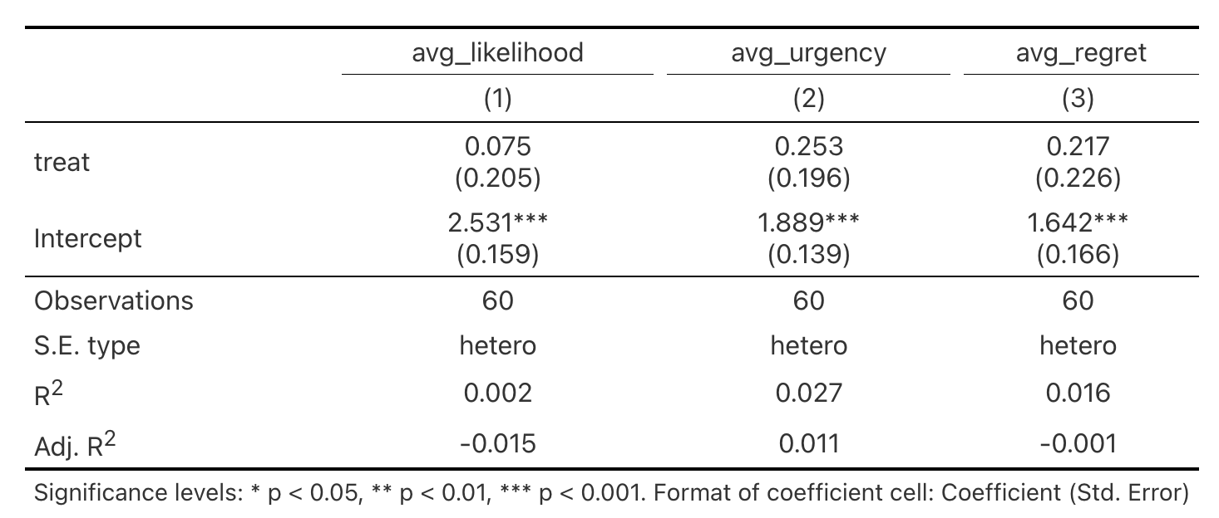
Table A1
Consistent with the descriptive results shown in Table A1, the estimated treatment coefficients are positive for all outcomes: +0.075 for purchase likelihood (SE = 0.205), +0.253 for perceived urgency (SE = 0.196), and +0.217 for anticipated regret (SE = 0.226). However, none of these coefficients are statistically significant at conventional levels, so we fail to reject the null hypothesis that scarcity messaging has no effect on purchase likelihood, urgency, or anticipated regret in this sample.
In the baseline specification, the intercept $α$ is statistically significant in all three regressions because it estimates the control-group mean of each outcome (i.e., the expected rating when $treatment_{i }= 0$). The significance test for the intercept is $H_{0}:α= 0$. Because our dependent variables are measured on a 1–5 Likert scale, the control-group averages are naturally far from zero (roughly between 1.6 and 2.5 in our data), and the associated standard errors are small, producing large t-statistics and very small p-values. However, this statistical significance is not insightful for our research question since rejecting $H_{0}:α= 0$ only tells us that the control group’s mean rating is not zero, which is an unsurprising result given the scale and not a meaningful benchmark for consumer behavior. The substantive hypothesis concerns the treatment effect β\betaβ, which tests whether scarcity messaging shifts outcomes relative to the neutral message.
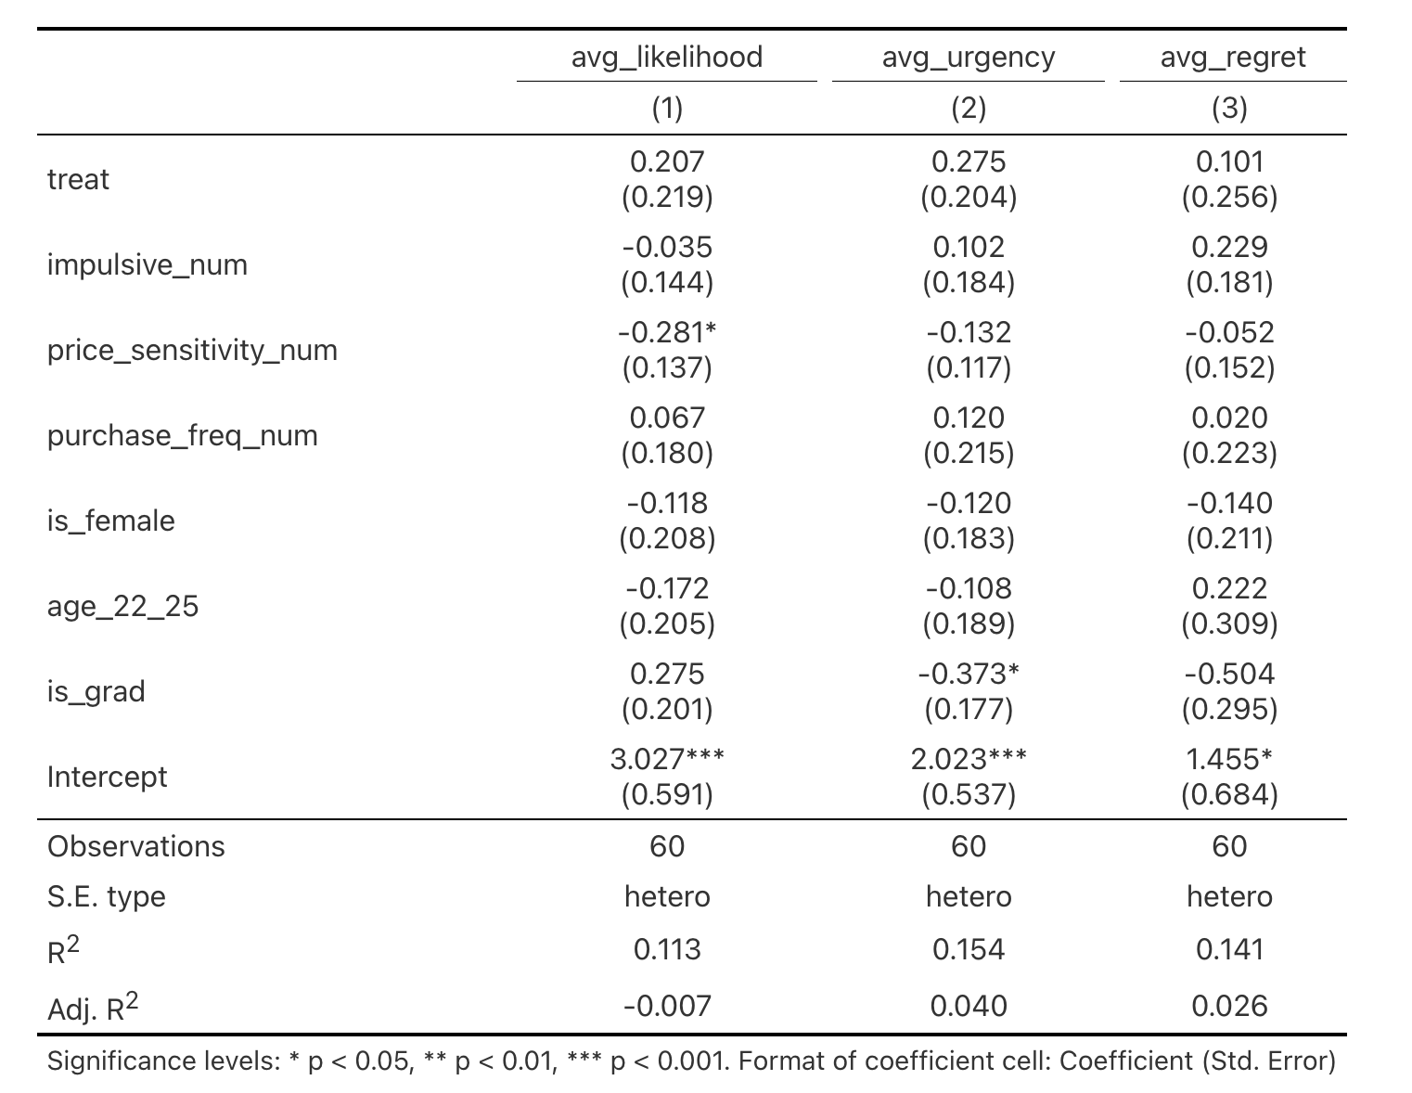

Table A2

As a robustness check, we estimated extended OLS models that included individual-difference covariates (impulsiveness, price sensitivity, online purchase frequency) and demographic controls (gender, age group, and graduate status). In the respondent-level models highlighted in Table A2, the treatment coefficients remain positive but not statistically significant for likelihood (0.207, SE = 0.219), urgency (0.275, SE = 0.204), and regret (0.101, SE = 0.256).
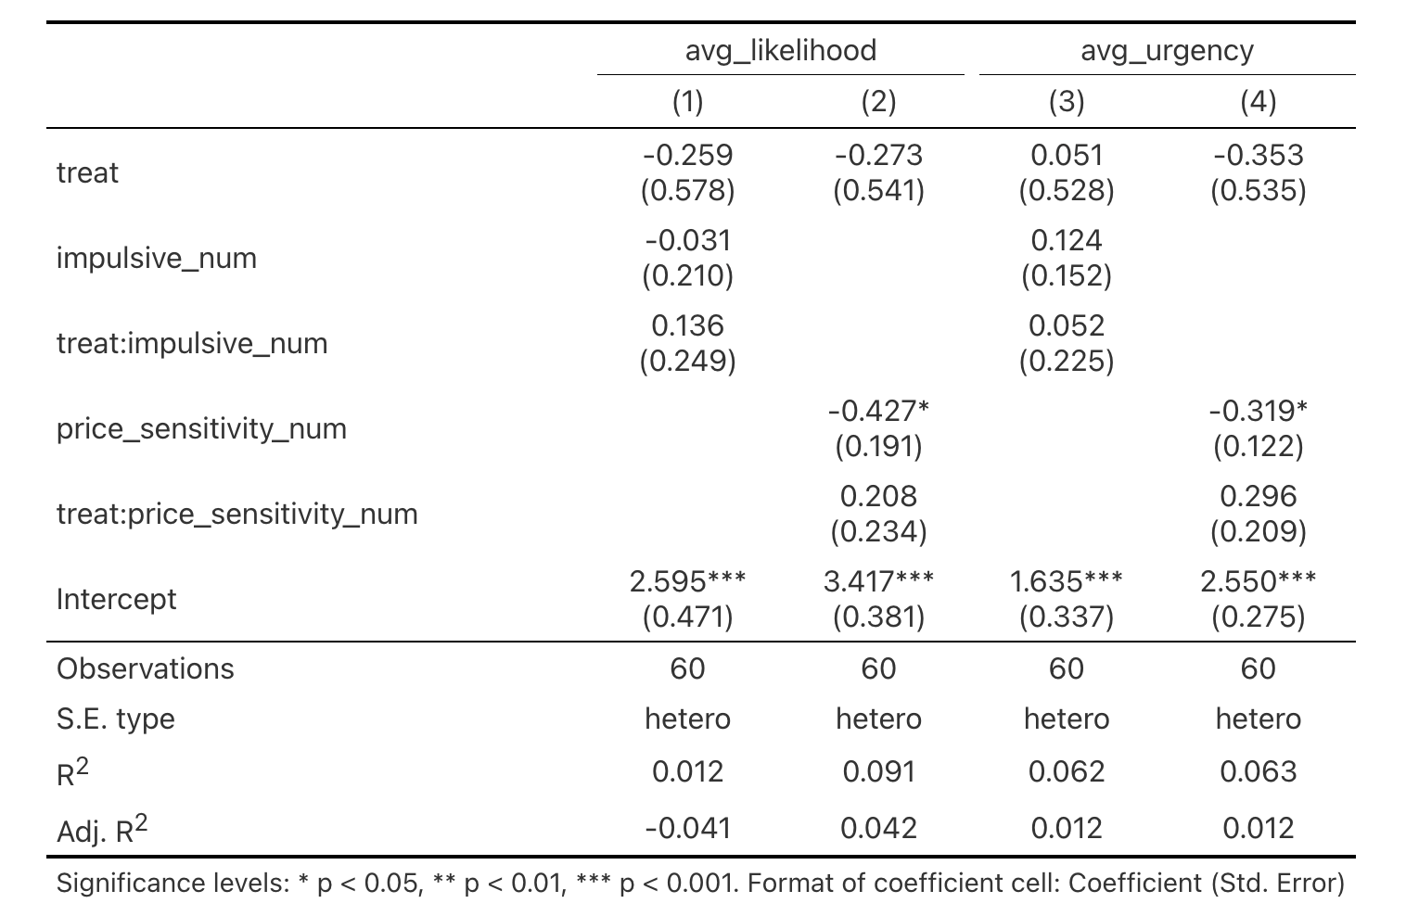
Table A3

We also tested heterogeneous treatment effects by interacting treatment with impulsiveness and price sensitivity in Table A3, and we found that these interaction terms are not statistically significant and therefore provide no evidence that the scarcity effect differs systematically across these traits.
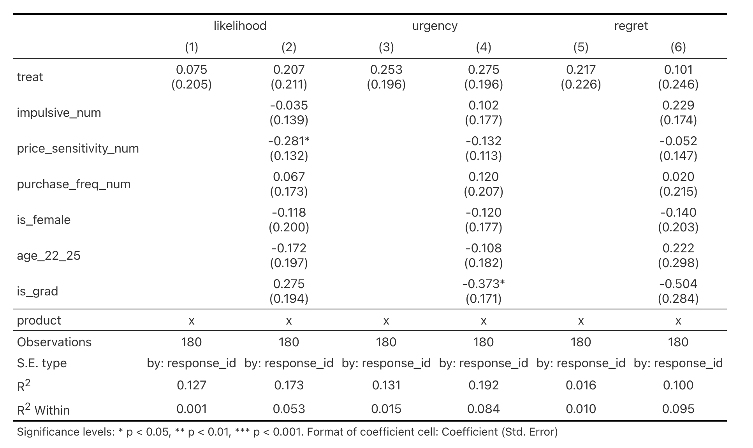
Table A4
In addition, using the long-format dataset with product fixed effects and standard errors clustered by respondent (N=180N=180N=180), the treatment estimates remain statistically insignificant both without and with covariates (Table A4).
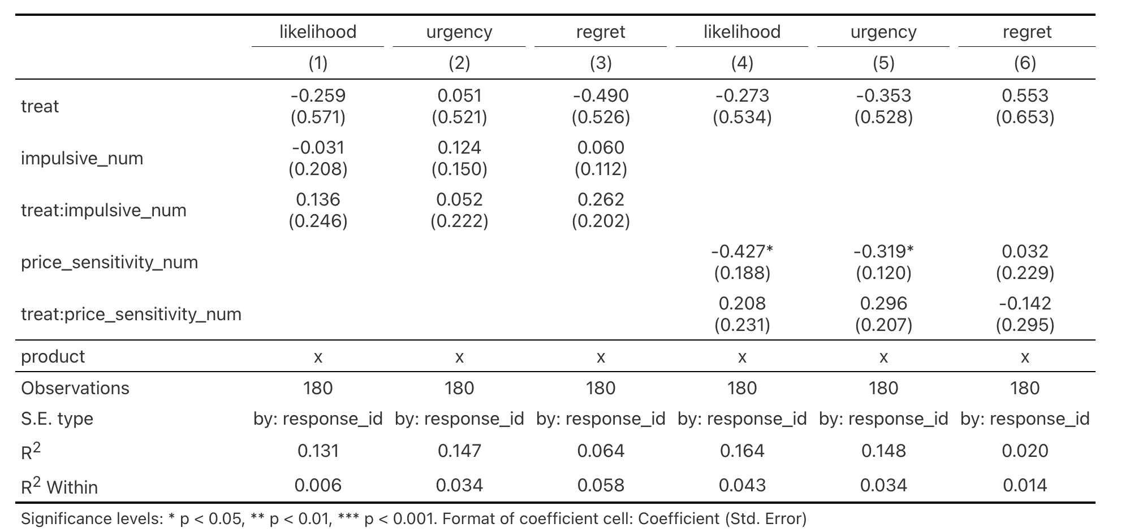

Table A5

Finally, long-format interaction models again show no statistically significant treatment-by-trait interactions (Table A5). This finding shows that across specifications, price sensitivity is consistently negatively associated with purchase likelihood, and graduate status is associated with lower urgency.
Overall, the results provide suggestive but inconclusive evidence in the hypothesized direction. While scarcity messaging is associated with higher average urgency and anticipated regret (and slightly higher purchase likelihood), the estimated effects are not statistically significant, implying that the observed differences could be due to sampling variation. A larger sample size may be necessary to more precisely estimate treatment effects and detect potentially small effects of scarcity messaging on consumer responses.
Limitations
This study provides a foundational understanding of college students (ages 18–25) and their perceptions on stock availability, product scarcity, and decision-making regarding necessities and nonessential products across different price ranges. However, a major limitation in this project’s experiment lies in the design of the survey questionnaire. In particular, while the objective of the study was to target individuals ages 18–25 who are currently college students, a design flaw in the survey was that respondents were only allowed to identify themselves as either Undergraduate or Graduate. There was no option indicating that a respondent might not currently be enrolled in college, which presents a questionnaire flaw that could result in inaccurate classification of participants and potentially biased results.
Another challenge that we faced was that by the end of the experiment, we had a total of 95 responses, yet after filtering out incomplete surveys and those who were ages 26 or older, we were only left with 57 completed surveys. To address this issue, we had to resend the survey to three to five additional individuals ages 18 to 25 to reach the minimum required sample size.
Ultimately, due to time constraints, the survey was distributed using a convenience sampling method so selection bias was involved to a certain extent. The team shared the survey link with their classmates and personal connections and through online platforms (MSBA shared Slack channel) and social media accounts (i.e. Instagram). As a result, the sampling population primarily consists of college students located in the northeastern region of the US, limiting sample heterogeneity and reducing demographic and geographic diversity within the dataset.

Appendix
Survey link: https://bostonu.qualtrics.com/jfe/form/SV_02JPoYIySMPiPvE

Demographics:
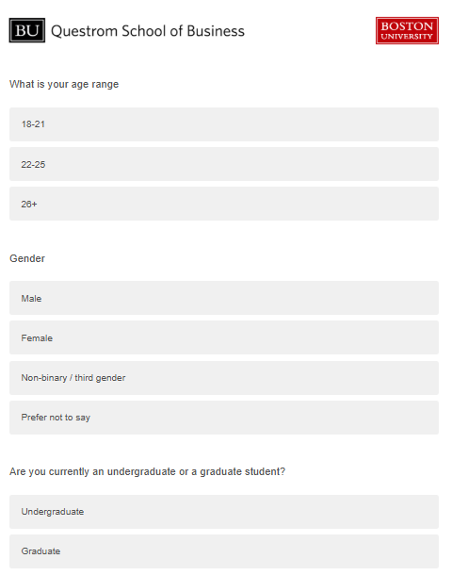

Product Sensitivity Questionnaire:
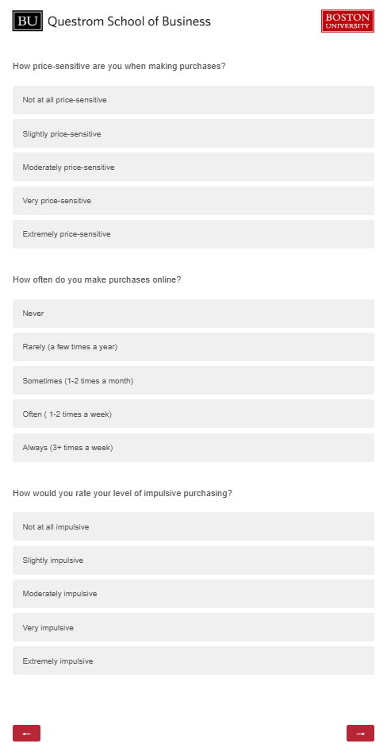

Purchase Behaviors:
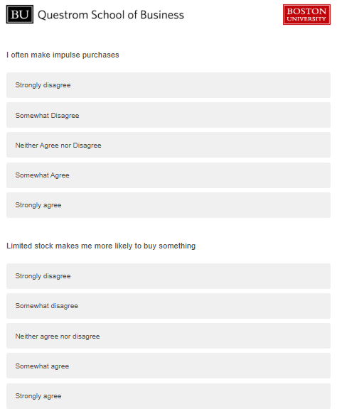
Product Specifications: Only 3 Left vs In Stock
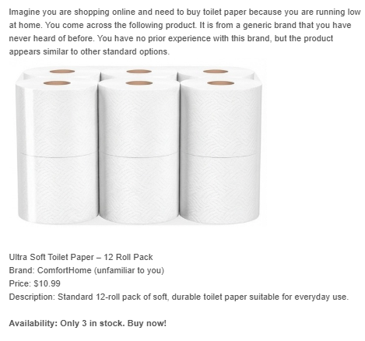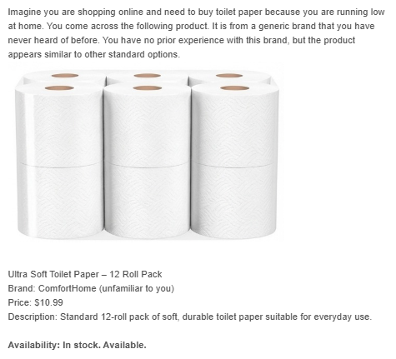
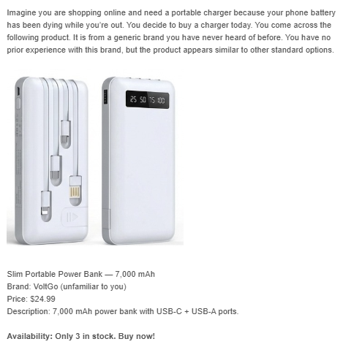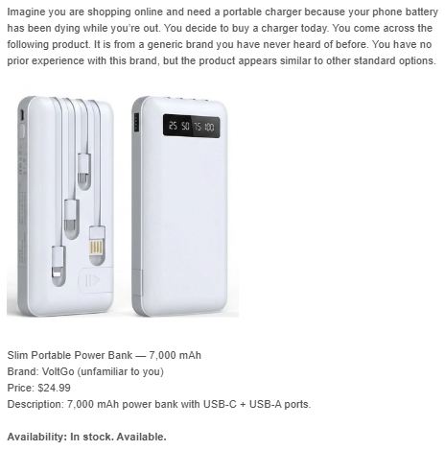

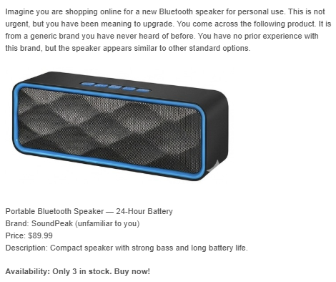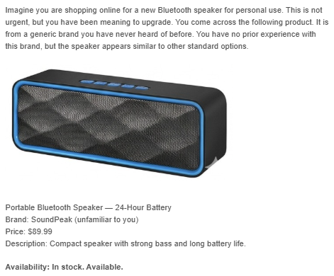

Purchase Intention & Regret:
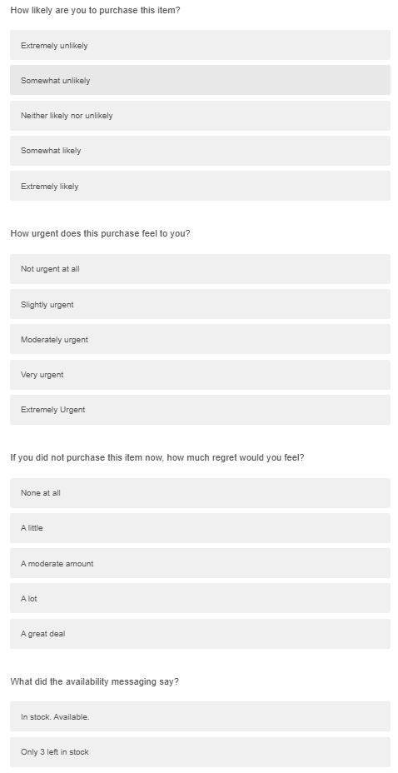

Final Paper Rubric
Final Paper (70% of grade)

I expect the final paper to be about 7 pages single spaced / 14 pages double spaced, including tables and figures.

You can use any document creation package you like (word, LaTeX, etc), but the final paper must be submitted as a Word Document or a PDF.

You can use any citation style you like.

Please make sure to create publication‑quality figures and tables. That means that figures must be labeled properly, tables must look good, and variables should be properly named. For example, while your code may have a variable called ‘any_treatment’, your figure should say ‘Treatment’.

There is no template because your experiments are so different, what needs to be discussed at length in some cases won’t need to be discussed at all in others, etc. Use your judgment about what it is important to describe: what you did, the academic literature, the conclusions you have drawn from the data, why these conclusions are justified, and potential limitations. Reviewing some of the academic papers we read this term may help remind you what it is typical to see in experimental write‑ups.

All writeups should answer the following.

• Your research question.
• What specific hypothesis you test.
• What your treatment was and how you randomized it.
• What your outcome was and how you collected it.
• How you analyzed the data.
• Your results and interpretations of the results.
• Any limitations you are aware of.

You don’t need to use every concept we learned or will learn this semester. However, if you do not use at least one of the concepts in the list below, then please pick at least one and write one paragraph about why you did not need to use the concept or could not use the concept:

• Blocking
• Clustering
• Using covariates to increase precision
• Failure to treat
• Heterogeneous treatment effects

Context (Anna)

1. Research Question
Main research question:
Does the presence of scarcity-related messaging influence consumers’ purchasing decisions?

2. Hypothesis (Erica)

3. Treatment & randomization (Erica)

4. Outcome & data collection (Pin-Chen)
- Talk about the questionaries

5. Analysis (Mika)

6. Results & interpretation (Rita)

7. Limitations (Anna)

Deadlines
Upcoming Deadlines
Brief or verbal proposal for experiment approved by me (by February 12).
• Have you run a pilot study? (by February 19)
• Have you run the experiment? (by February 24)
•Presentation (March 5)
•Writeup (End of Day March 5)

BA830 Final Project
BA830 Final Project – Experimental Design & Execution Plan

1. Research Question
Main research question:
Does the presence of scarcity-related messaging influence consumers’ purchasing decisions?

2. Hypothesis
Primary hypothesis (H1):
Participants exposed to scarcity messaging (e.g., “Last day of sale,” “Only one item left”) will show a higher likelihood of purchasing the product compared to participants who are not exposed to such messaging.

3. Experimental Design
Design type:
- Between-subject randomized experiment
Conditions:
- Control group:
  - Product information shown without scarcity-related language.
- Treatment group:
  - Identical product information, with added scarcity messaging.
Scarcity manipulation text (draft):
- Control wording:
“This product is currently available for purchase.”
- Treatment wording:
“This is the last day of the sale. Only one item remains.”
Randomization method:
- Participants will be randomly assigned to either the control or treatment condition using the survey platform’s built-in randomization feature.

4. Outcome Measures
Primary outcomes:
- Purchase intention (Likert scale, 1–7)
- Purchase decision (Yes / No)
Secondary outcomes (if applicable):
- Willingness to pay (numeric input)
- Quantity willing to purchase

5. Sample & Data Collection Plan
Target population:
- Age range: (e.g., 18–30)
- Recruitment source: (friends, classmates, online, etc.)
Sample size goal:
- Minimum: 30 participants per condition (60 total)
- Target: 70-80 total (to account for dropouts / invalid responses)
Data collection tool:
- ☐ Qualtrics
- ☐ Google Forms
- ☐ Other: _______
[From here, to be filled later]

6. Covariates & Additional Measures
(Used to improve precision and support interpretation)
- Product need / relevance (1–7)
- Online shopping frequency
- Price sensitivity
- Basic demographics (age range, etc.)

7. Pilot Study Plan
Pilot size:
- 2–4 participants
Purpose of pilot:
- Check clarity of wording
- Ensure scarcity manipulation is noticeable but realistic
- Confirm survey flow and timing
Planned revisions after pilot:
- (To be filled after pilot)

8. Analysis Plan (Preliminary)
Main analysis:
- Compare mean outcomes between treatment and control groups.
- Regression framework:
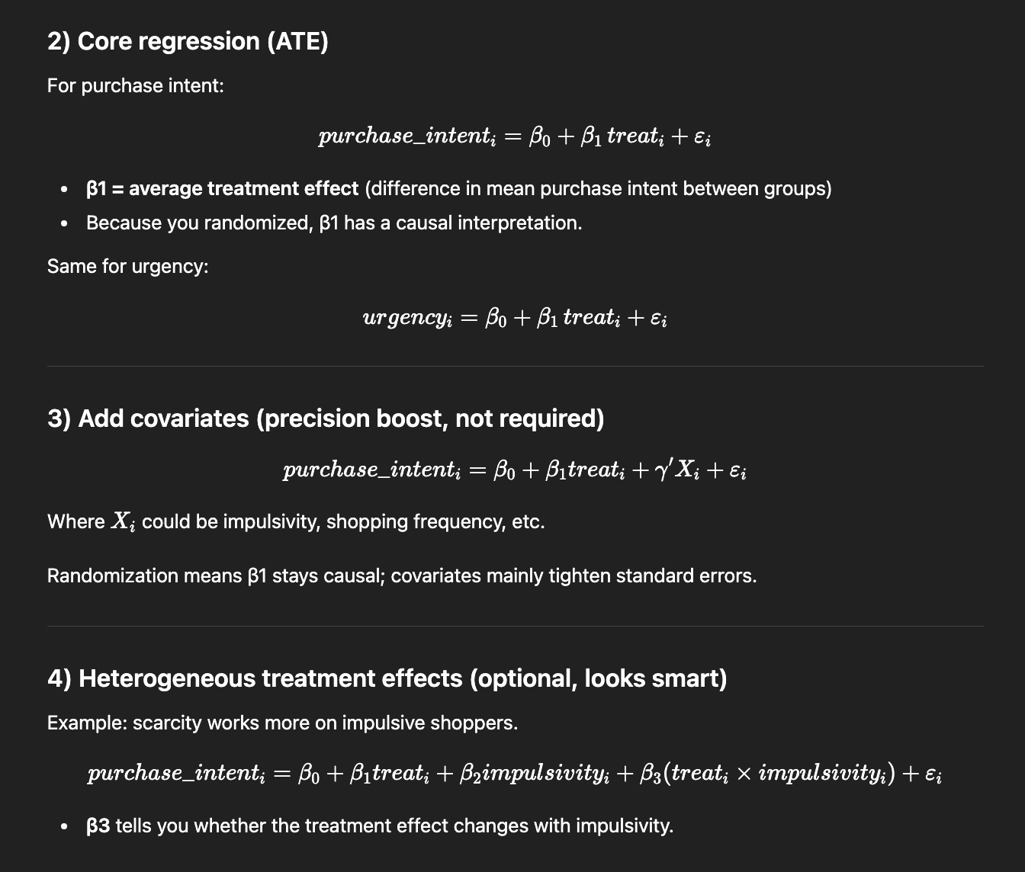
Additional analyses (if data allows):
- Heterogeneous treatment effects (e.g., by price sensitivity)
Concepts from class addressed:
- ☐ Using covariates to increase precision
- ☐ Heterogeneous treatment effects
- ☐ Other / explanation if not used

9. Limitations & Scope
Anticipated limitations:
- Hypothetical purchase setting vs. real purchase behavior
- Sample limited to a specific age group
- Limited sample size
How we will frame these in the paper:
- (Short notes for later expansion)

10. Timeline & Responsibilities
- Design finalized by: ___
- Pilot completed by: Feb 19
- Data collection completed by: Feb 24
- Analysis & slides: ___
- Final presentation & paper: March 5
Task assignments:
- Survey setup:
- Data collection:
- Analysis:
- Writing / slides:

11. Product Selection Strategy
Chosen approach (need to be discussed w prof):

- ☐ Single neutral product (e.g., USB-C charger / wireless mouse)
- ☐ Hypothetical purchase scenario with generic product
- ☐ Randomized product from a small product set

Erica notes
- Only the scarcity line differs
Data we collect:
Product need / relevance (1–7)
Prior purchase experience for this product category (Yes/No)
=> Include “product need” as a covariate to improve precision and to show effects are not driven solely by high-need respondents.

- Two Treatment (time pressure + low stock)

Treatment (3 product)
Affordable
More expensive (laptop) -> price range also impact
Add the price ranges
(age range)
Purchase behavior
Regret
How good is the deal
Would you buy now or not (yes or no)
Time track

Survey Questionnare Draft
Demographic Questions
What is your age range?
- 18-21
- 22-25
- 26+
Select gender
- Male
- Female
- Non-binary / third gender
- Prefer not to say
Are you currently an undergraduate or a graduate student?
- Yes
- No

Purchasing Behavior
How price-sensitive are you when making purchases?
- Not at all price-sensitive
- Slightly price-sensitive
- Moderately price-sensitive
- Very price-sensitive
- Extremely price-sensitive
How often do you make purchases online?
- Never
- Rarely (a few times a year)
- Sometimes (1-2 times a month)
- Often (1-2 times a week)
- Always (3+ times a week)
How would you rate your level of impulsive purchasing?
- Not at all impulsive
- Slightly impulsive
- Moderately impulsive
- Very impulsive
- Extremely impulsive
I often make impulse purchases
- Strong disagree
- Somewhat disagree
- Neither agree or disagree
- Somewhat agree
- Strongly agree
Limited stock makes me more likely to buy something
- Strong disagree
- Somewhat disagree
- Neither agree or disagree
- Somewhat agree
- Strongly agree

Product Questions
Product One (Necessity/Low Price): Toilet Paper
Scenario: You are running out of toilet paper and need to buy more online. There are two generic brands of toilet paper that you have never heard of. Both options are identical in quality, number of rolls, and price. Which one would you choose?
- Brand A – fully stocked
- Brand B — only 3 packages left

Product Two (Everyday Convenience /Mid Price): Power Bank/ Portable Charger
Scenario: You are in need of a portable charger and decide to purchase one from a store. On the shelf, there are two generic brands of portable chargers that you’ve never heard of. Both chargers look similar and are the same price. Which portable charger would you purchase?
- Brand A —The shelf is fully stocked with many units available.
- Brand B — Only 3 units remain on the shelf.

Discretionary / Higher price: Bluetooth Speaker
Scenario: You are in the market for a new Bluetooth speaker. You are looking at two different brand options that you’ve never heard of before. The online shop you’re on has both speakers that are the same size and share the same battery life and performance.
- Speaker A: Fully stocked.
- Speaker B: Only 3 units remaining

Survey link: https://bostonu.qualtrics.com/jfe/form/SV_02JPoYIySMPiPvE

